Bahria University,

Karachi Campus



LAB EXPERIMENT NO.

___06___

LIST OF TASKS

|  |  |
| --- | --- |
| TASK NO | OBJECTIVE |
| **01** | Write what you have learned in few lines on each of the three programs that were using the *fork()* system call. |
| **02** | Write a C program that uses *fork()* system call to print a single line eight times without using *for* loop and repeated *printf* command. |
| **03** | Code the C program given below and explain what it does along with providing a snapshot of the output. Investigate and write about the usage of *execlp()* system call. |
| 04 | Write a program to find sum of even numbers in parent process and sum of odd numbers in child process. |

Submitted On:

20-04-2023

(Date: DD/MM/YY)

**Task 01:** Write what you have learned in few lines on each of the three programs that were using the *fork()* system call.

**Explanation:**

I have learned and understand about fork() that this is a system call and this is used to display 2^n statement without for loop. This is used for return many statement by fork(). This is used to create new thing, means child class and it returns parent and child method. The fork() is return values, if return value is in negative then the child process is not successful and if return valus is equal to 0 then it return both parent and child statement.

**Task 02:** Write a C program that uses *fork()* system call to print a single line eight times without using *for* loop and repeated *printf* command.

**Solution:**

#include<stdio.h>

#include <sys/types.h>

#include<unistd.h>

int main(){

fork();

fork();

fork();

printf("My name is Shoaib Akhter \n");

return 0;}

**Output:**

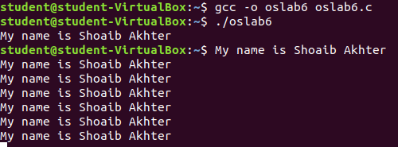

**Task 03:** Code the C program given below and explain what it does along with providing a snapshot of the output. Investigate and write about the usage of *execlp()* system call.

**Solution:**

#include<stdio.h>

#include<string.h>

#include<sys/types.h>

#include<unistd.h>

#include<stdlib.h>

int main(){

int pid;

pid = fork();

if (pid < 0) {

fprintf(stderr, "Fork failed!\n");

exit(-1);}

else if (pid == 0) {

printf("I am the child, return from fork=%d\n", pid);

execlp("/bin/ls", "ls", NULL);}

else {

printf("I am the parent, return from fork, child pid=%d\n", pid);}}

**Explanation:**

Here is the output where first call parent and then child and when child is called then execute this statement “execlp("/bin/ls", "ls", NULL);” then this statement shown all files in output and here is three parameters.

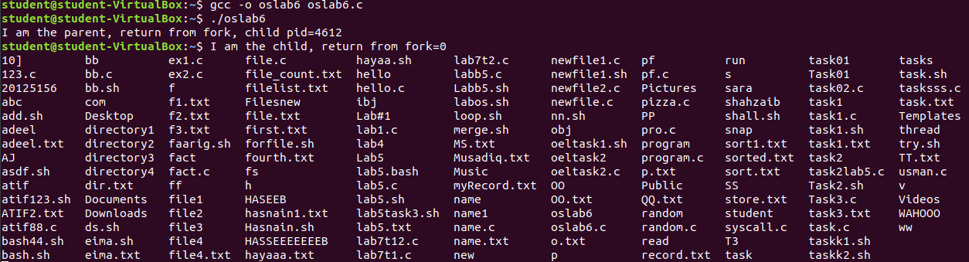**Output:**

**Task 04:** Write a program to find sum of even numbers in parent process and sum of odd numbers in child process.

**Solution:**

#include<stdio.h>

#include<string.h>

#include<sys/types.h>

#include<unistd.h>

#include<stdlib.h>

int main(){

int add=0,pid,odd=0;

pid = fork();

if (pid < 0) {

fprintf(stderr, "Fork failed!\n");

exit(-1);}

else if (pid == 0) {

for(int i=1;i<=10;i+=2){

odd+=i;}

printf("The sum of odd Numbers from 1 to 10 is %d \n",odd); }

else {

for(int i=0;i<=10;i+=2){

add+=i;}

printf("The sum of Even Numbers from 0 to 10 is %d \n",add);}}

**Output:**

